Here we made a custom array list

Which to be declared private, which to be declared public, variable declaration, everything is nicely done here

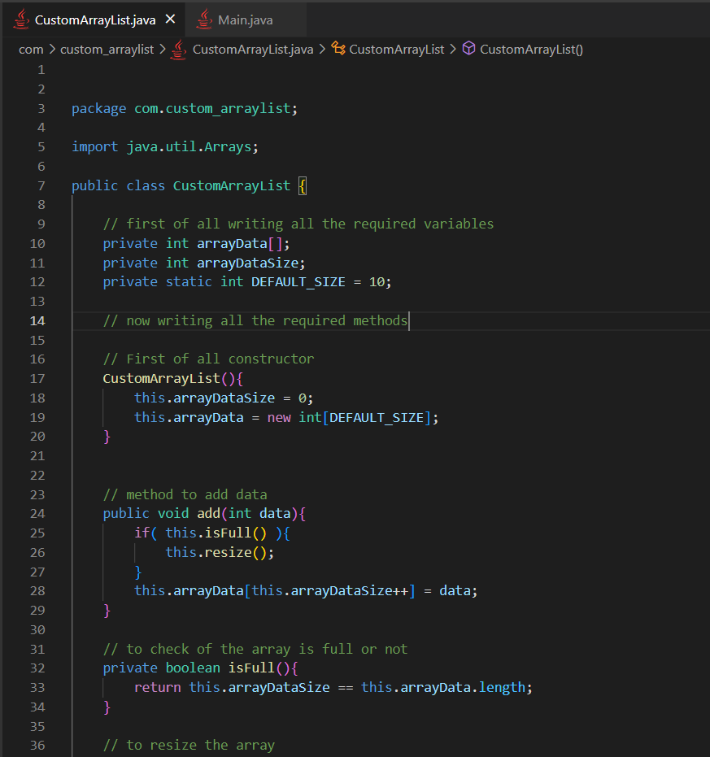

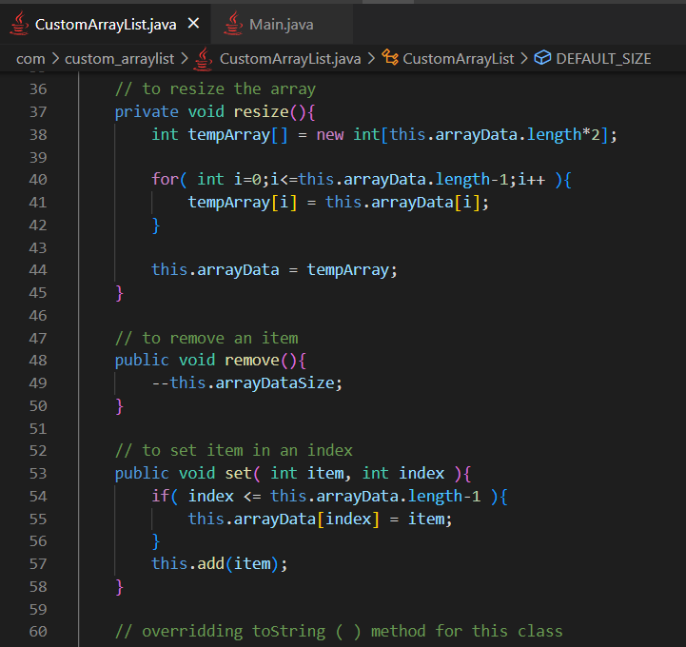

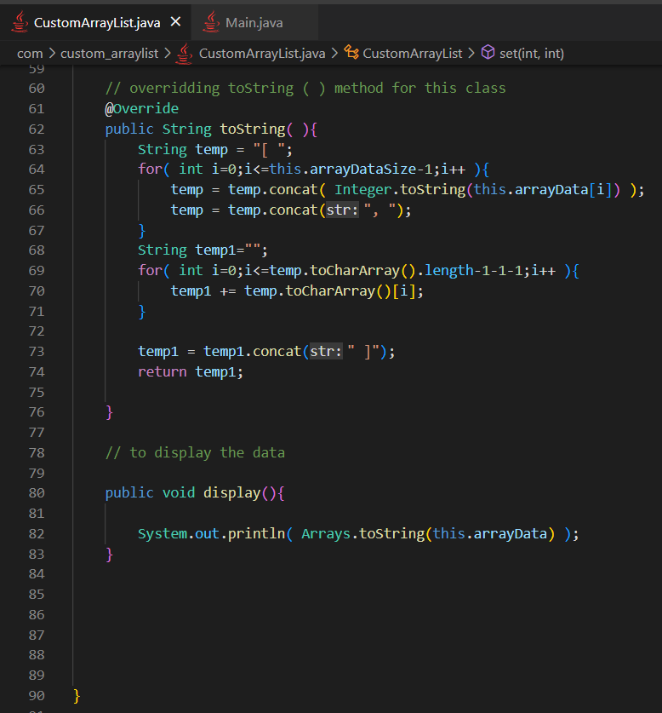

**Problem with this custom array list and the need of generics**

1. Here we can only store integer types, but an actual array list must be able to store characters, string, objects ( references ) , floats etc

An internal array list already present java allows us to store data of any types

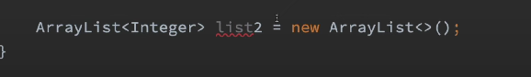

See here we were able to pass the data type as : <Integer>

1. This functionality to pass the data types while making the ArrayList is knows as generics